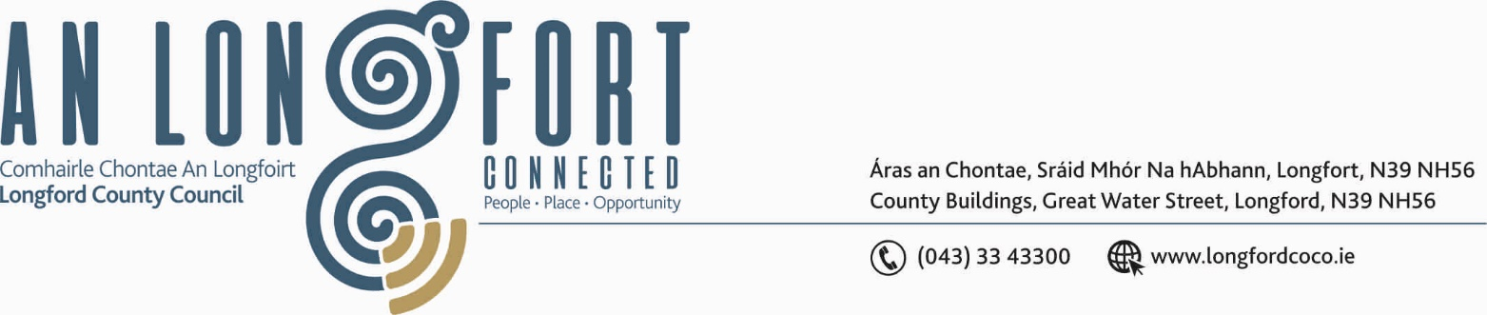

LONGFORD MUNICIPAL DISTRICT

Please bring your iPads to all meetings, fully charged, to allow for access to meeting supporting documentation.

18th June 2020.

To: Each Member of Longford Municipal District.

Dear Member,

You are requested to attend Meeting of Longford Municipal District to be, held in the
Sports Hall, Leisure Centre, Albert Reynolds Peace Park, Longford Wednesday,
24th June 2020 at 3.00 p.m. to transact business, as set out on the Agenda hereunder.

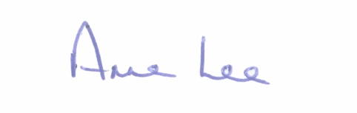
Yours sincerely,

_______________
Anne Lee,
Meetings Administrator.

AGENDA

Prayer before meeting.

- Confirmation of Minutes of meeting of Longford Municipal District held on
the 27th May 2020 - enclosed.

- Matters arising from Minutes.

- Declaration of Interest by Members.

- Management Report - enclosed.

- Consideration of the taking in charge of Roads at Mastertech Industrial Estate – map and report enclosed.

- Licensing of street furniture in the vicinity of hospitality related premises.

- 2020 Community Grant Support Scheme- St. Mel’s Musical Society
Correspondence enclosed.

- Re-commencement of paid parking in Longford town – report enclosed.

- Notices of Motions, submitted by Councillors, as listed hereunder –

Councillor John Browne.

“St. Mels College boundary ditch along the Ballinalee Road is overgrown, unsightly and obstructing the view into the college grounds.
I call on Longford County to consider availing of funding under the Town and Village Renewal Scheme, so as the tidy up the ditch, remove debris, replant the gaps, and leave uniform.”

Councillor Uruemu Adejinmi.

“I call on the County Council to give the streets in the town centre a deep clean - power wash the streets and shop entrances. This will give the town a fresh, clean & inviting look for customers post Covid and help to sanitise the surroundings.
A concerted effort should also be made by the Council to ensure all local businesses become involved in maintaining shop/house fronts.”

“I call on the County Council to facilitate street markings in front of business entrances and ATMs on the town’s main streets. This will help encourage social distancing and for uniform markings across town”

Councillor Martin Monaghan.
“To examine the junction coming from Ballymakeegan exiting on to Lisduff Hill.
To upgrade road markings and signage. The junction has seen serious accidents in the last few years.”

“Could we look at doing the Road from Briskill Cross to Cloontagh as this road is in terrible condition. There is a lady who is blind and cannot get a Guide Dog approved until the road surface is done as it is a trip hazard as it stands.”

- A.O.B.

